Point-to-Point :-

* Point-to-point networks contain exactly two hosts such as computers, switches or routers, servers connected back to back using a single piece of cable.
* If the hosts are connected point-to-point logically, then they may have multiple intermediate devices.



Bus Topology:-

* All devices share a single communication line or cable.
* Bus topology may have problems while multiple hosts sending data at the same time.
* Bus topology uses CSMA/CD technology
* It is one of the simple forms of networking where a failure of a device does not affect the other devices.
* But failure of the shared communication line can make all other devices stop functioning.

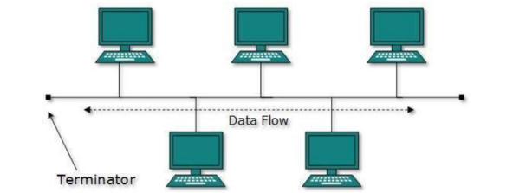

Star Topology :-

* All hosts in Star topology are connected to a central device, known as hub device, using a point-to-point connection.
* That is, there exists a point to point connection between hosts and hub.
* Layer-1 device such as hub or repeater
* Layer-2 device such as switch or bridge
* Layer-3 device such as router or gateway

Definitions:-

1. **Hub**: A device that connects multiple Ethernet devices, broadcasting data to all ports indiscriminately.
2. **Repeater**: A device that extends the reach of a network by regenerating and amplifying signals.
3. **Switch**: A networking device that connects devices and directs data to specific physical ports based on MAC addresses.
4. **Gateway**: A device that connects and translates communications between different network protocols.
5. **Bridge**: A device that connects and filters traffic between network segments at the data link layer.
6. **Router**: A device that routes data packets between different networks based on IP addresses.

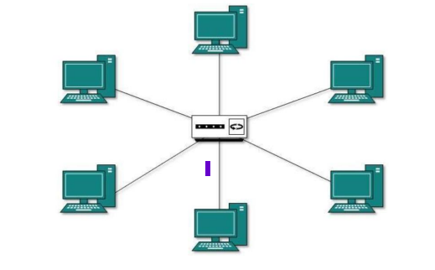

Ring Topology:-

* In ring topology, each host machine connects to exactly two other machines, creating a circular network structure.
* When one host tries to communicate or send message to a host which is not adjacent to it, the data travels through all intermediate hosts.

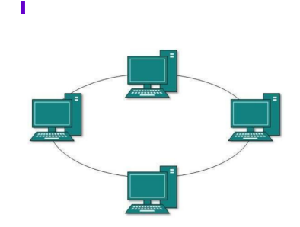

Mesh Topology:-

* Host is connected to one or multiple hosts
* This topology has hosts in point-to-point connection with every other host or may also have hosts which are in point-to-point connection to few hosts only.

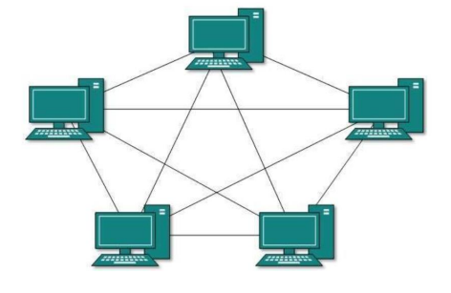

* Full Mesh: All hosts have a point-to-point connection to every other host in the network. Thus for every new host n(n-1)/2 connections are required. It provides the most reliable network structure among all network topologies.
* Partially Mesh: Not all hosts have point-to-point connection to every other host. Hosts connect to each other in some arbitrary fashion. This topology exists where we need to provide reliability to some hosts out of all.

Tree Topology:-

* Also known as Hierarchical Topology, this is the most common form of network topology in use presently.
* This topology imitates as extended Star topology and inherits properties of bus topology.
* This topology divides the network in to multiple levels/layers of the network.
* lowermost is an access-layer
* middle layer is known as the distribution layer
* highest layer is known as the core layer

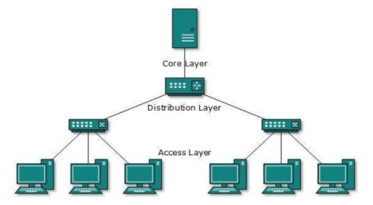

Daisy Chain:-

* This topology connects all the hosts in a linear fashion.
* Similar to Ring topology, all hosts are connected to two hosts only, except the end hosts.
* Every link failure splits the network into two segments



Hybrid Topology:-

* A network structure whose design contains more than one topology is said to be hybrid topology.
* The combining topologies may contain attributes of Star, Ring, Bus, and Daisy-chain topologies.
* Internet is the best example of largest Hybrid topology

